Republic of the Philippines

**EULOGIO “AMANG” RODRIGUEZ**

**INSTITUTE OF SCIENCE AND TECHNOLOGY**

**Cavite Campus**

General Mariano Alvarez, Cavite

Final Term Project

in

OBJECT-ORIENTED PROGRAMMING (OOPRGLAB)

*Barangay Management System*

**Submitted by: Group IV**

Leader:

Pareñas, Thrizia May B.

Members:

De Jose, Roland Emmanuel

Turan, Idyl

**Submitted to:**

Mr. William Ferdinand L. Zareno

(Instructor)

**TABLE OF CONTENTS**

A.) Database Proposal …………………………………………………………………………………………………………….

a.) Objective ……………………………………………………………………………………………………………….

b.) The brief ……………………………………………….…………………………….………………………………...

c.) Software, Hardware, and User Requirements…………………………………………………………..

B.) Database Graphical User Interface……………………………………………………………………………………..

I. Startup of the application…………………………………………………………………………………………

II. Log in and User Validation………………………………………………………………………………………..

III. Welcome window…………………………………………………………………………………………………..

IV Home window…………………………………………………………………………………………………………

V Functions…………………………………………………………………………………………………………………

1. Dashboard button……………………………………………………………………………………………
2. Organization button………………………………………………………………………………………..
3. Resident Record button…………………………………………………………………………………..
4. Reports button………………………………………………………………………………………………..
5. Contact Us button……………………………………………………………………………………………
6. Account button……………………………………………………………………………………………….
7. Add account button…………………………………………………………………………………………
8. Logout button………………………………………………………………………………………………….
9. Minimize button………………………………………………………………………………………………
10. Maximize button……………………………………………………………………………………………..
11. Close button……………………………………………………………………………………………………

**A.) Database Proposal**

Barangay Management System

**a.) Objective:**

Create a system that will help the barangay to improve the operation process of recording and managing the information of individuals and census of the population and make an easy way for the request of documents. Secure the file records including evidence of personal data.

**b.) The brief:**

The brief is to make a system to properly manage the records of the barangay such as a List of Officials, Resident List, Request of Certification, and Reports of Records. The system should also allow end users valid for the protection of the information. This is to avoid manual systems such as saving files made on paper that can decrease storage space like filing cabinets and other office space

**Reasons for publishing the system:**

* Poor management of records
* Difficulties in requesting certification
* Lack of authorizations
* Struggle in organizing reports
* Time-consuming transactions

**c.) Software, Hardware, and User Requirements**

**Software:**

* + - Microsoft office (For the database and exporting of the document)
    - Sub-requirements are built-in or automatically installed on the computer.

**Hardware:**

* + - Desktop set (at least 4GB Ram)
    - Printer (For Documentation and Reports)

**User:**

* Must be computer literate

**B.) Database Graphical User Interface**

(Following screenshots are based on the sample database currently used for Demonstration)

**I. Startup of the application**

This window will show as you open the application.



**II. Log in and User Validation**

The application is password protected for the protection of data and information. User levels are also applied.

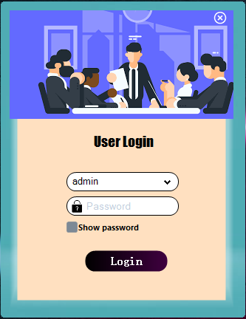

Login Process:

1. Choose the username from the **combo box.**
2. Enter the password.
3. Click the **Login button.**

Reminder:

Failure of entering the correct username and password 3 times will cause the system to shut down.

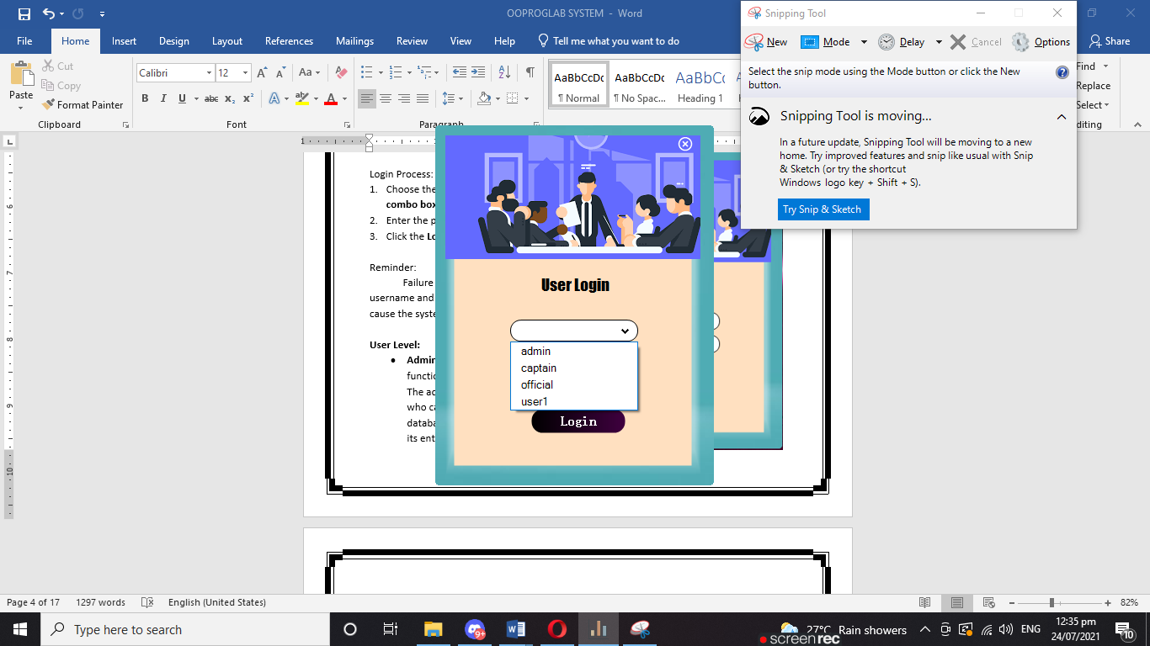

**User Level:**

* **Admin –** Can access every function of the application. The admin is the only one who can add new users to the database and delete its entire system.
* **Captain** – Can access every function of the application except for adding new users to the database and erasing the existence of the application.
* **Official** – Can access almost entirely that the captain can access except by changing the password of the account. This function is exclusively only for the admin and the captain.
* 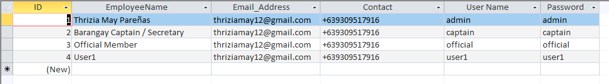**User** – Can access everything but for viewing purposes only. Won’t be able to add, create and delete records. Also, won’t be able to access the printing function such as certification and reports.

Note:

For password changes inside the application, the admin is the only one who can change every end user’s password since it’s the admin who knows all of the usernames and passwords. On the other hand, other end users can only change their password.

***For Admin Only:***

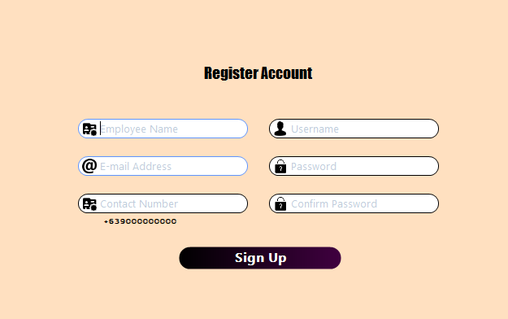**III. Welcome window**

A welcome window will follow up after a successful log-in. It’s either **sign-in** or **sign-out.**

* + **Sign in** – Will direct to the Home Window.
  + **Sign out –** Will direct back to the Login Form.

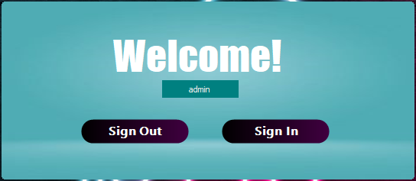

**IV Home window**

After signing in the home window will follow up. Below is the list of the functions inside the window.

10.)

9.)

11.)

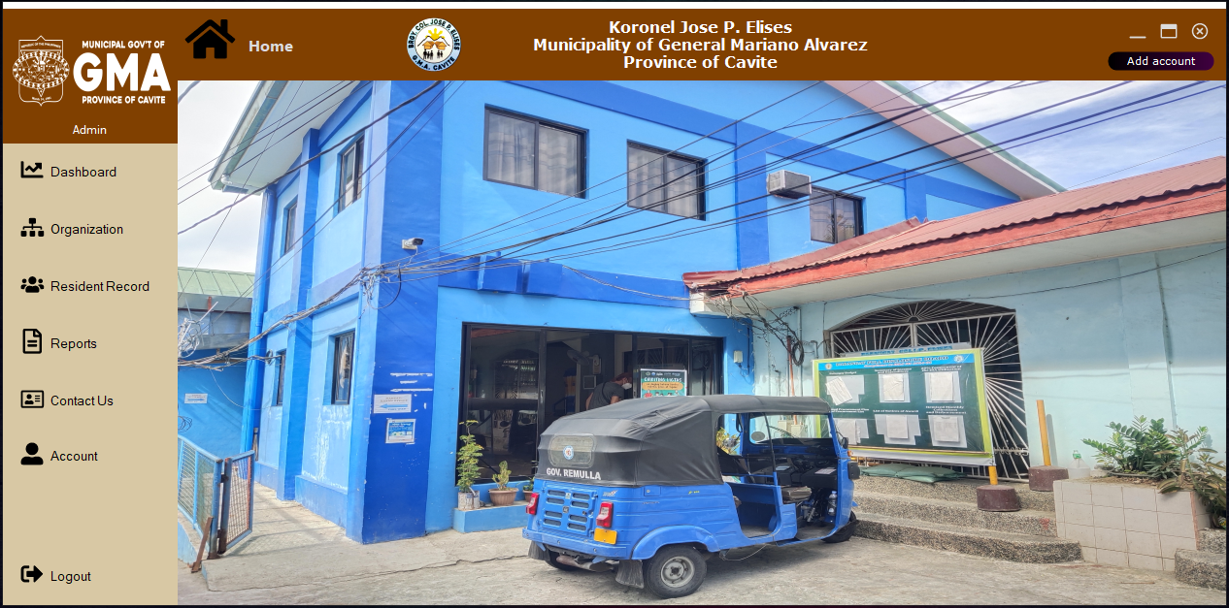

3.)

2.)

1.)

8.).)

7.)

4.)

5.)

6.)

**V Functions: On Home Windows>**

1. **Dashboard button** – For viewing the Vision, Mission, and Core Values Statement.

**Dashboard Form**

1. **Organization button** – List of the officials of the barangay that is available for editing (View only for the user). Example:

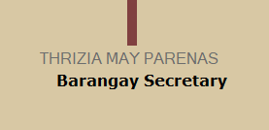

Process:

* 1. Click the **edit button**.
  2. Select the **name** you want to edit.
  3. Click the **save button**.

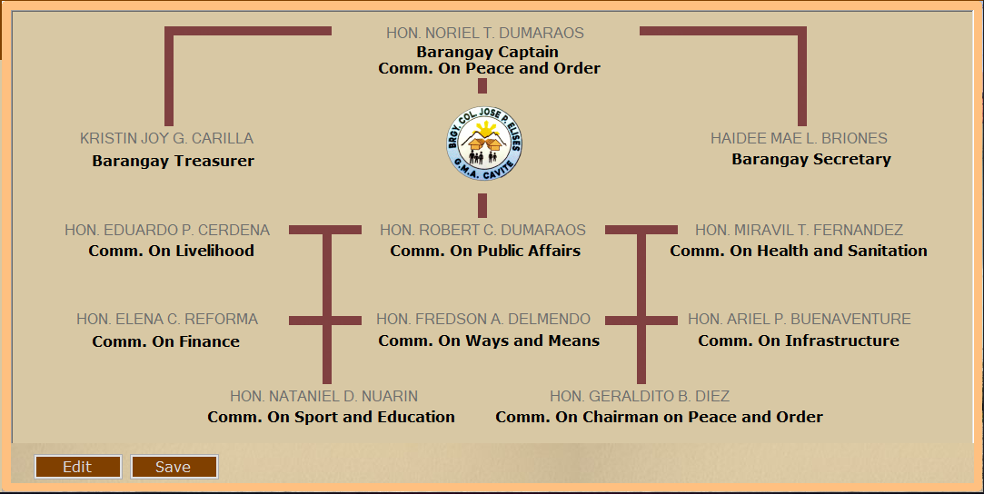**Organization Form**

1. **Resident Record button** - Resident list wherein you can view, search by name, add, update and delete the record. It also contains certification requests such as Barangay Clearance, Barangay Certificate, and Certificate of Indigency.

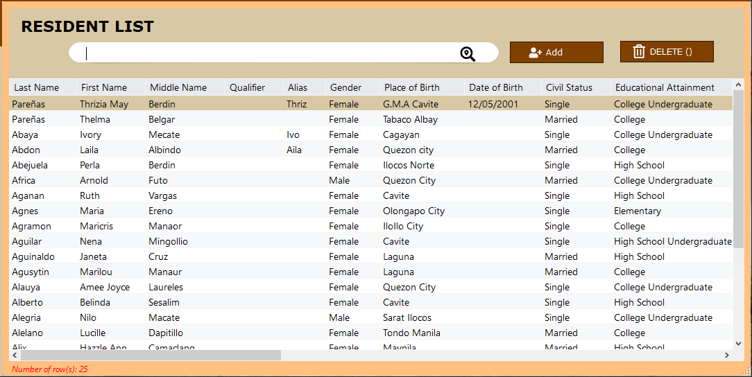**Resident Record Form**

**Adding New Record**

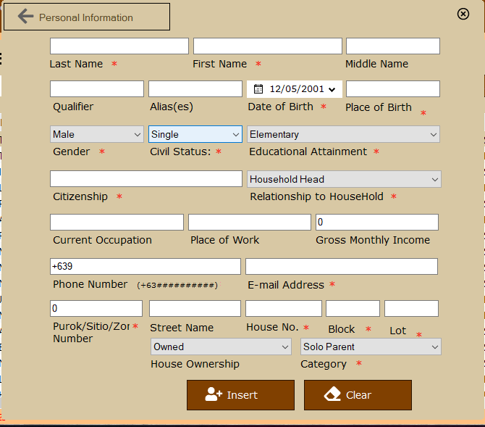Add record Process: **> On Resident Record Form**

1. Click the **add button** (Resident Record Form) then a **new window** will appear.
2. Fill up the form with your information. Note that those with “**\***” are required.
3. Click the **insert button.**
4. Click the **search button** to refresh the list. (Resident Record Form)
5. Additional: Click the **clear button** to clear all the

textboxes in case you made a lot of mistakes.

**Editing / Updating a Record**

Edit/Update Process: **> On Resident Record Form**

1. Double-click the **record** you want to edit (Resident Record Form). Then, a new window will appear with the information of the record you selected.

Example:

You want to update the “Alias” record of Pareñas.



1. Do your edit/update.

Example:

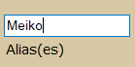

1. Click the **update button.**

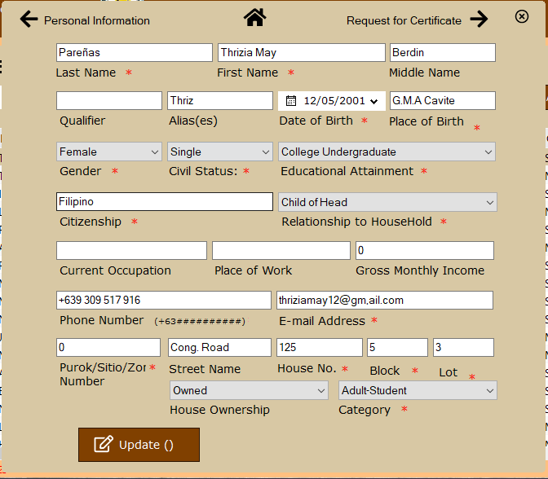

1. Click the **search button** to refresh the list.





**Deleting a Record**

Delete Process: **> On Resident Record Form**

1. Select the record you want to delete (Resident Record Form).

Example:

You want to delete the record of Alberto.

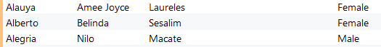

1. Click the **delete button**.



**On Resident Record > Update > Request Certification**

Certification Process:

1. Double-click the record for the certification (Resident Record Form). Then. A new form will appear.



1. Click **Request for Certificate**.



1. 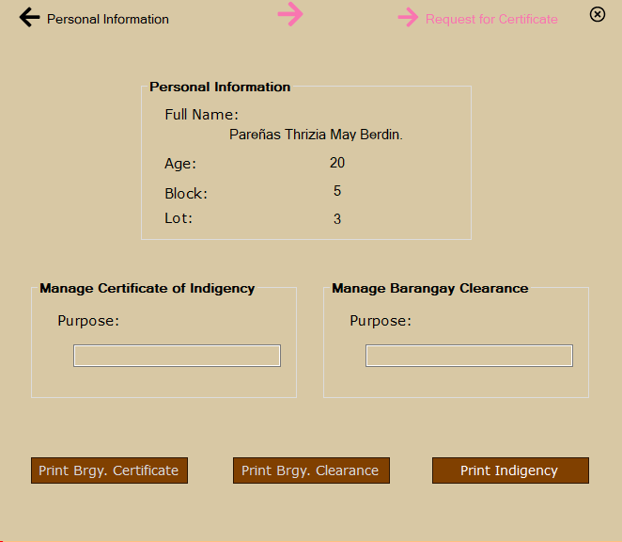Fill in the information for the purpose if needed
2. Choose and click the button on what type of certificate you want to request.

Example:

Indigency Purpose:

Scholarship

Clearance Purpose:

Employment

**EXAMPLE PREVIEW OF THE DOCUMENT**

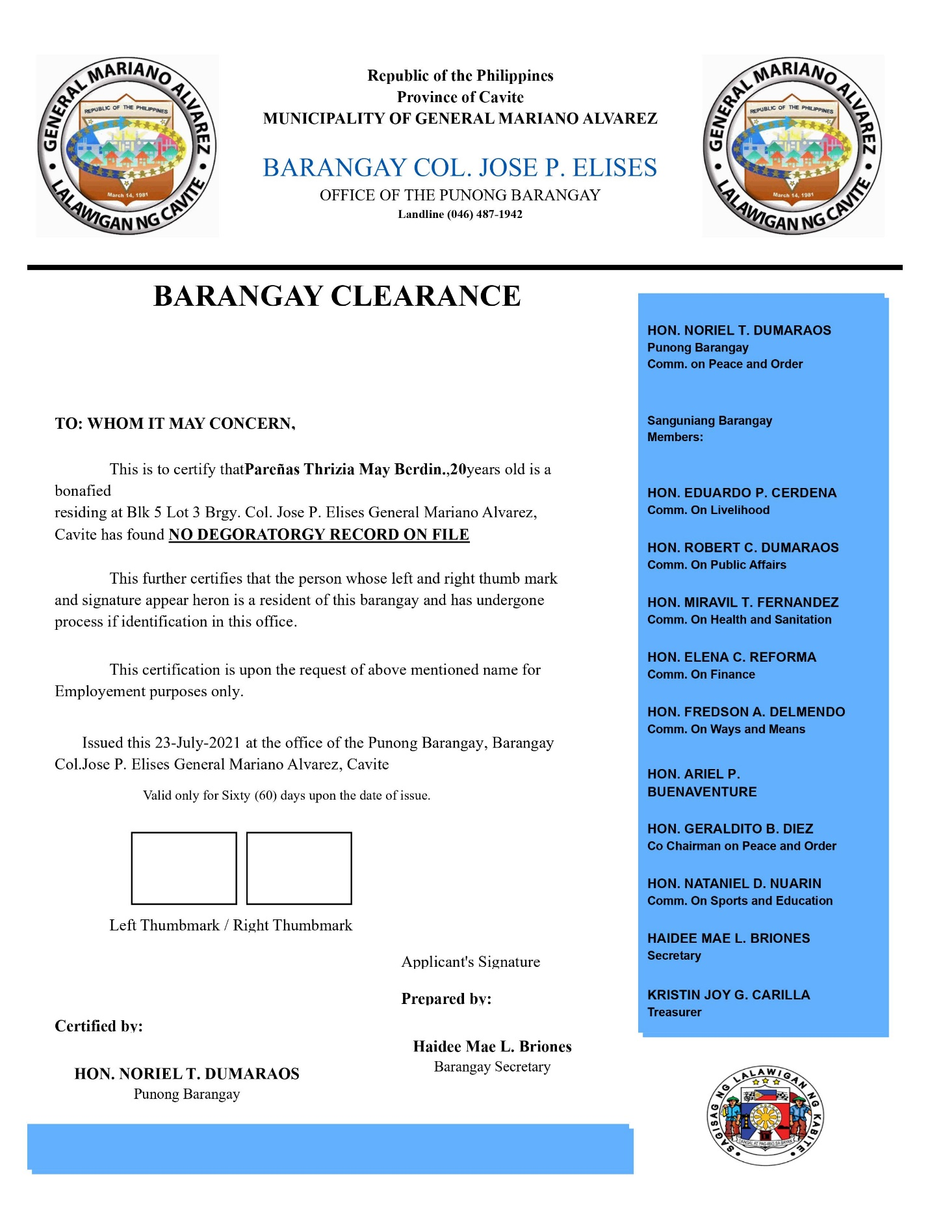***Print Brgy. Clearance Button***

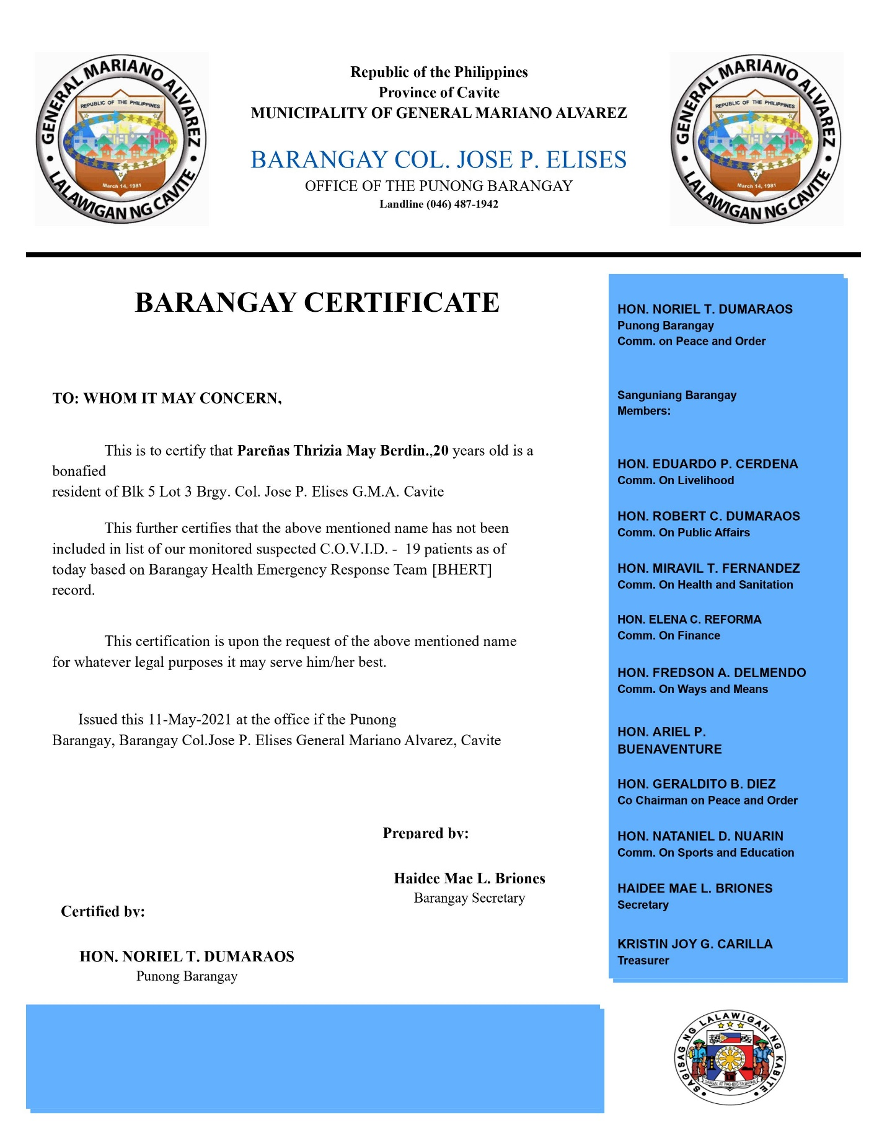***Print Brgy. Certificate Button***

***Print Indigency Button***

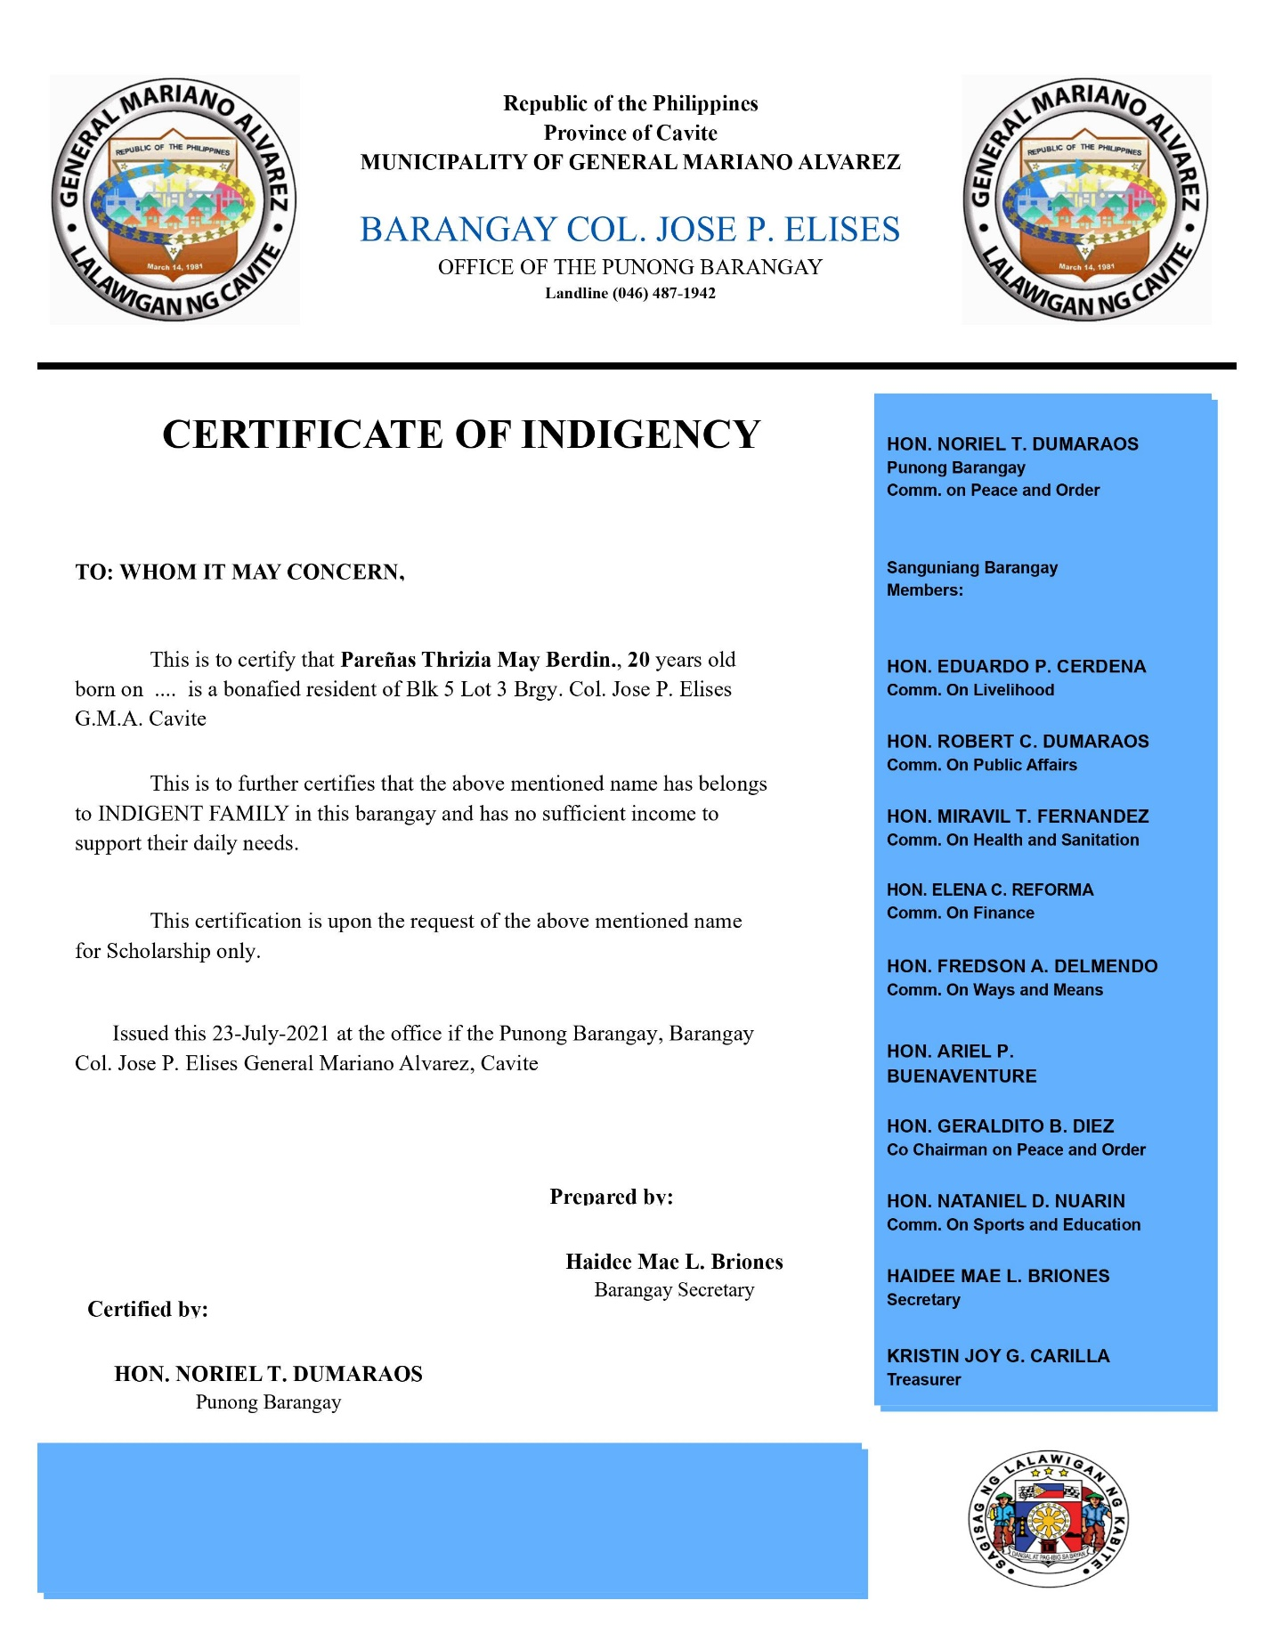

**Additionally:** You can directly print your document or export it through the toolbox on the top of the window or from its toolbar.

1. 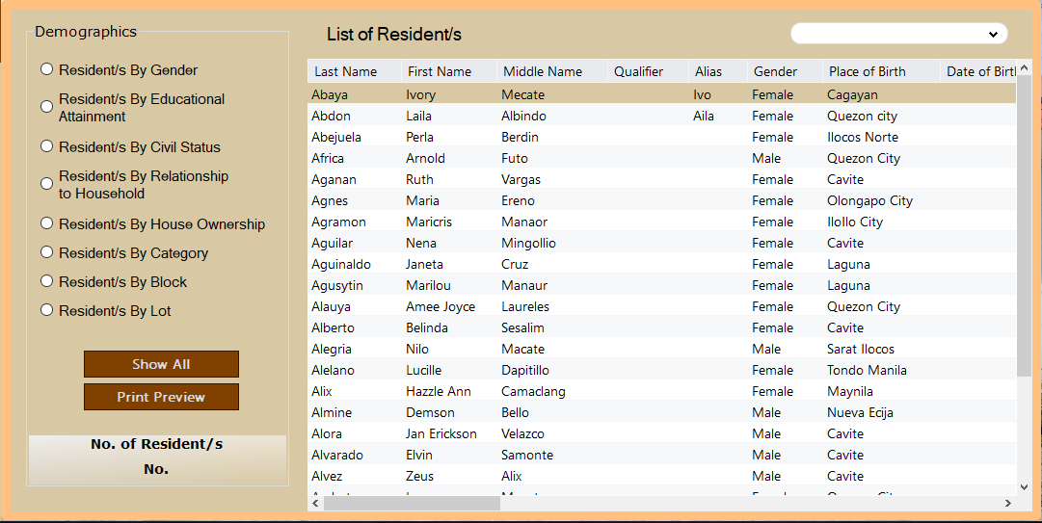**Reports button** – View the list of the resident with demographics and print them selectively. Made especially for organizing the records.

**Reports Form**

Print Report Process:

1. Select the **radio button** you want to preview.
2. Select from the given types shown in the **combo box**.

Note: After selection, the preview data will automatically change depending on the radio button that you have selected and its type from the combo box. Including only all contact information.

1. Click the **print preview button**. Then, a new window will appear.
2. Additionally: You can directly print your document or export it through the toolbox on the top of the window or from its toolbar.

Example:

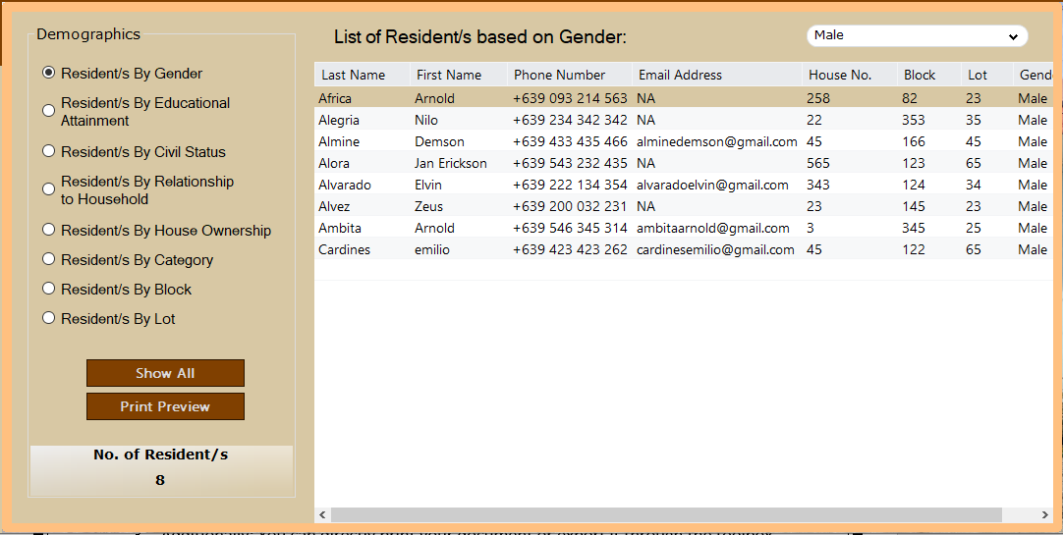 Demographics: By Gender > Male

**EXAMPLE PREVIEW OF THE DOCUMENT**

***Demographics: By Gender > Female***

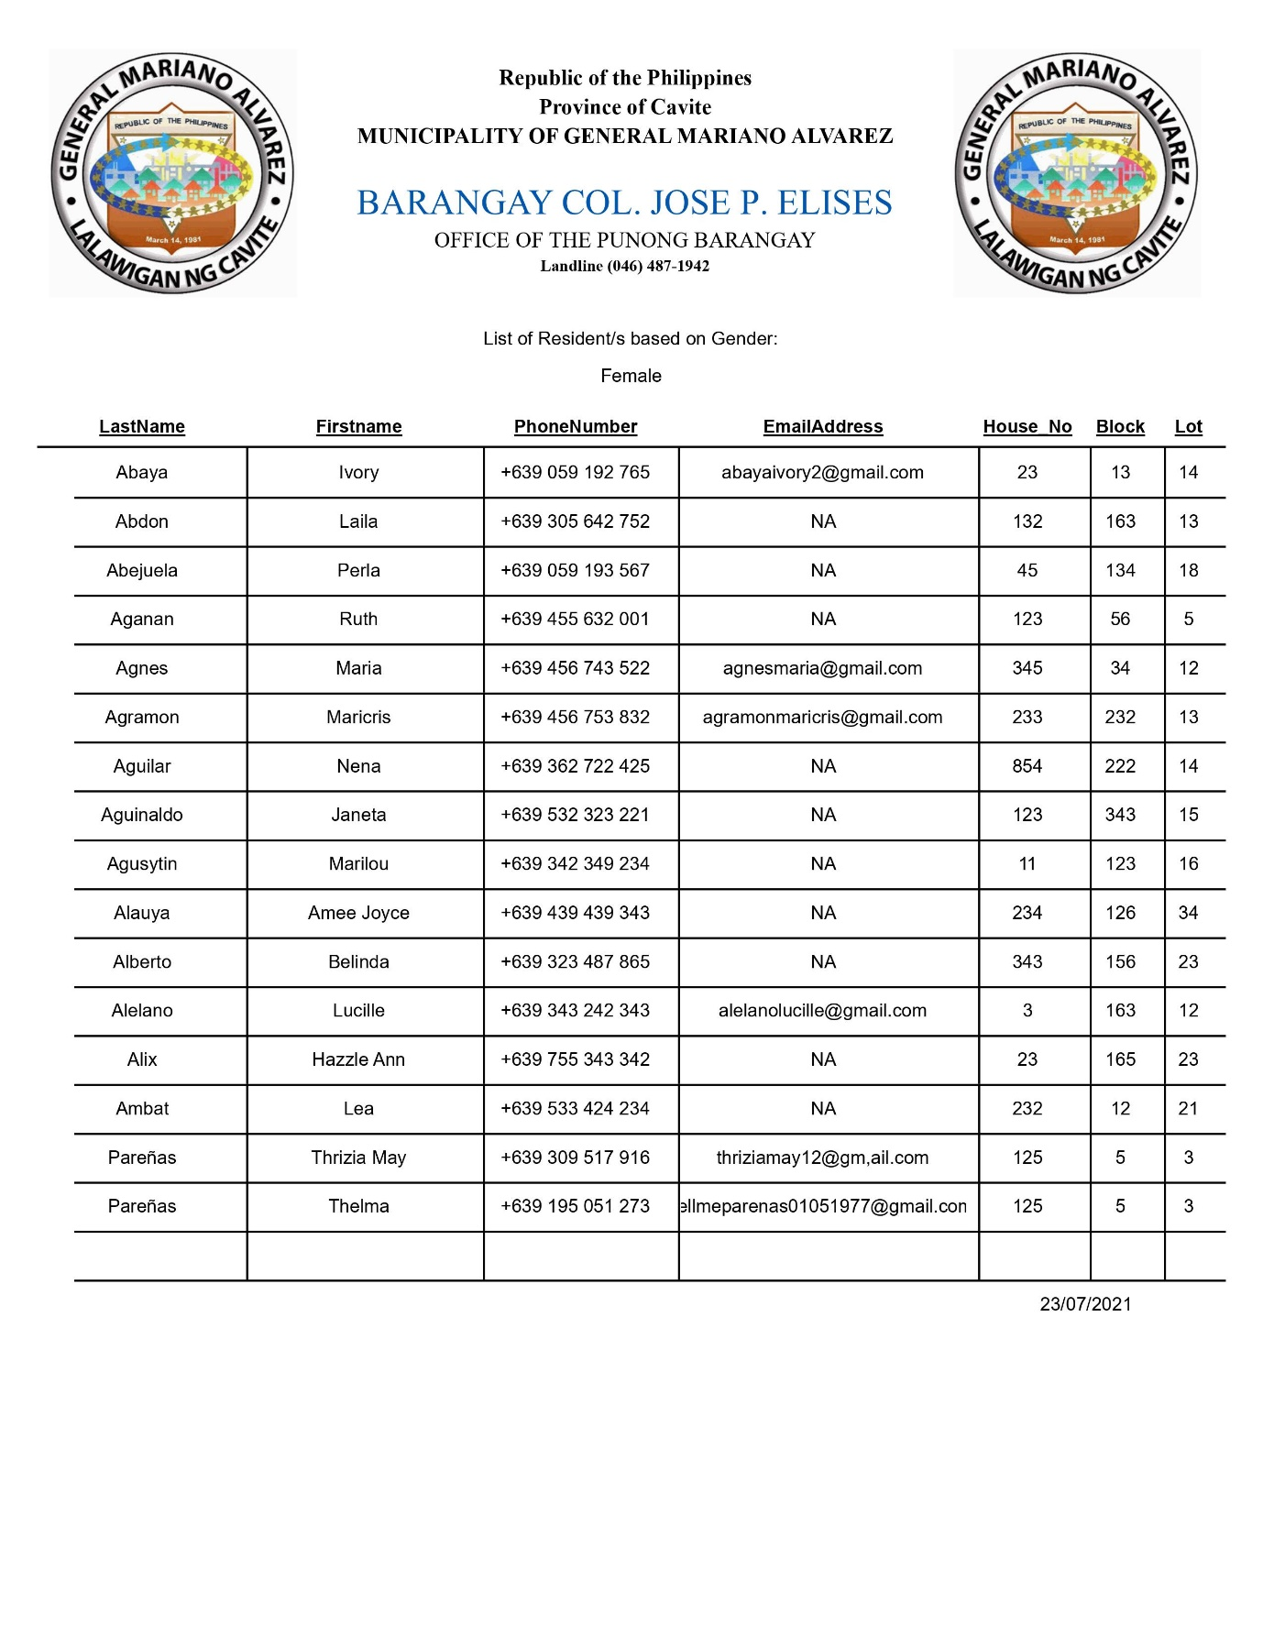

**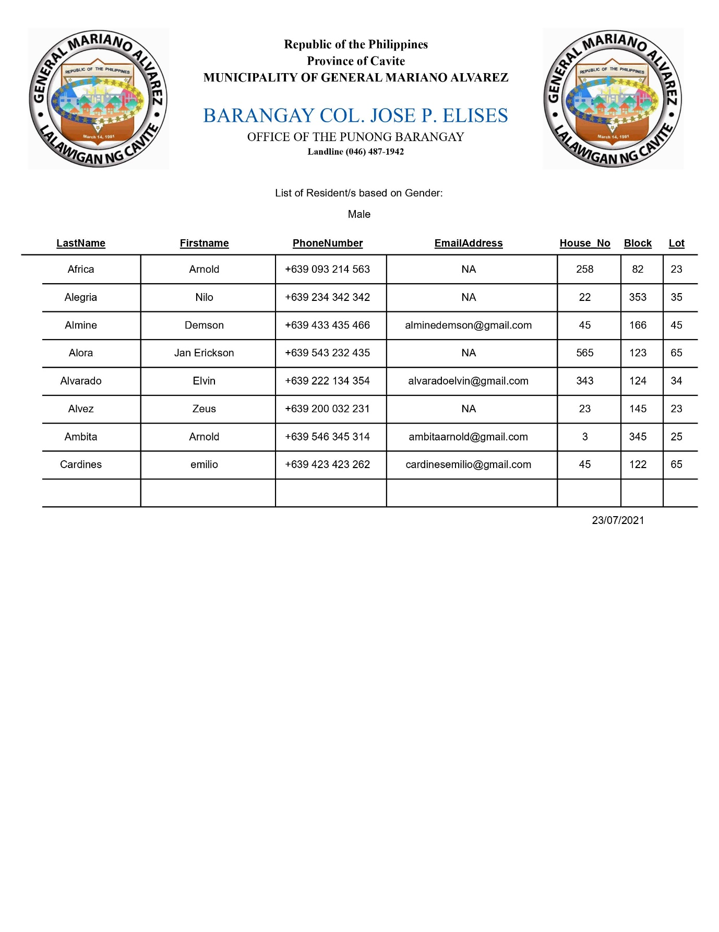*Demographics: By Gender > Male***

1. **Contact Us button** – Contains the map that encloses the barangay and the information where you can contact the barangay (Facebook, Instagram, Twitter, Email, Phone, and Book an Appointment).

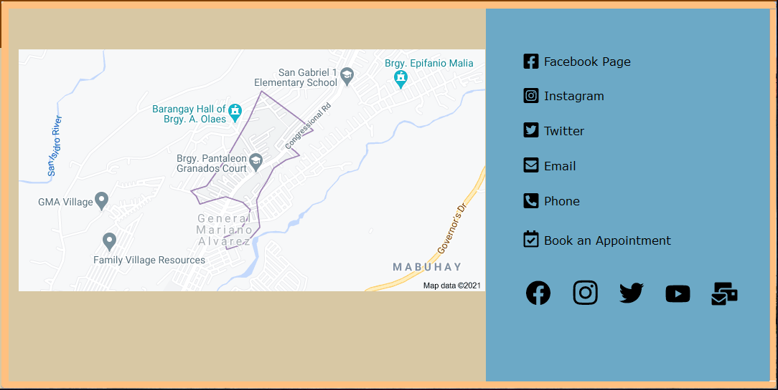**Contact Us Form**

Reminder: The link is still not available since the barangay that I choose does not have social accounts.

1. **Account button** – For Changing Passwords (Admin and Captain only)

Change Password Process:

1. Fill in the username and password for the account you want to change.
2. Enter your new password. Make sure that the confirmation password matches your new password.
3. Click **Change Password**.

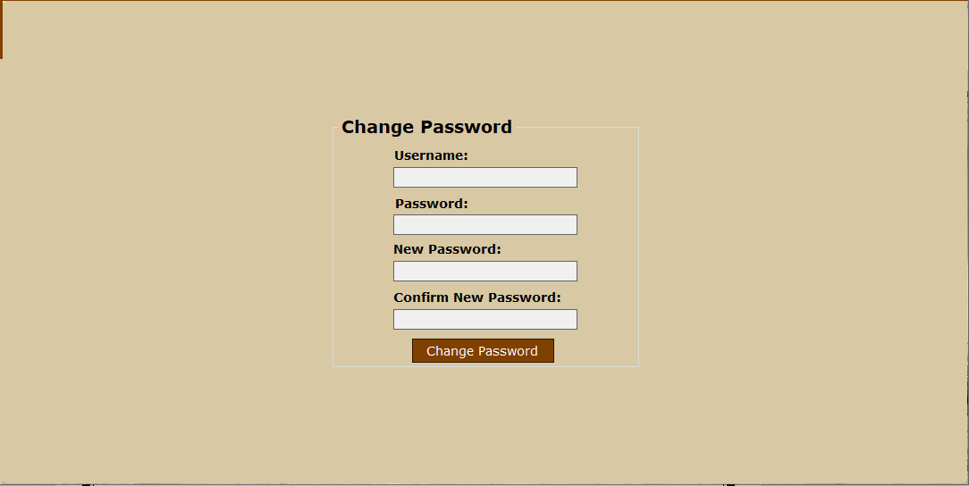**On Account> Change Password Form**

1. **Add account button** – Add new user exclusively only for admin.

Register Account Process:

1. Fill in the Personal information. Make sure they follow the proper format.
2. Enter the username and password that you want. Note that duplication of username won’t be accepted.

Reminder:

Password accepts a minimum of 5 characters and a maximum of 10 characters.

1. Click the **Signup button.**
2. Lastly, Login Again

**Add Account Form**

1. **Logout button** – Go back to the welcome form to sign out or sign in again.
2. **Minimize button** – Minimize the window.
3. **Maximize button** – Maximize the window.
4. **Close button** – Go back to Login Form for Closing the application.